**Lesson Notes**

1. What is the main purpose of an Operating System?

It is simpler and more efficient. The operating system handles the computer hardware and the system handles resource allocation

Also the consistent user experience is important because operating systems provide a standard user interface which is windows and provides a standard way to store

Another way is they allow multiple applications to run at the same time. They provide ownership control and operating systems schedules the CPU

1. What is the difference between Operating System Software and Use Application Software?

Hardware independence, same applications can run on different computer hardware and operating system must be configured according to hardware components present in the computer

User interface, Applications focus on what is contained and displayed within a window. Operating systems on the other hand controls opening/closing/ resizing windows and responding to mouse and keyboard actions.

Resource allocation, Applications just ask for what they need (example: memory, disk space) and operating systems checks for availability and access permission. Also operating system coordinates resource allocation between applications

1. What is the difference between Operating System Software and Computer Hardware?

Same applications can run on different computer hardware whereas operating System must be configured according to hardware components present in the computer

1. What are the main parts of an Operating System?

a. Graphical User Interface (GUI)

b. System Calls

c. Device Drivers

d. I/O Manager

e. Memory Manager

f.  Process Manager

g. Security Monitor

1. What are some popular operating systems?

a. Windows OS

b. Mac OS

c. Linux / Unix

d. Android

e. iOS

**Reference Diagram**

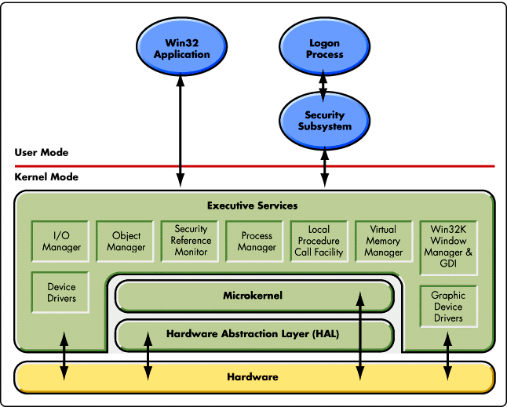

**Student Questions**

1. What is a device driver?
   1. Provide a brief summary

A device driver is a software program that controls a particular type of hardware device that is attached to a computer. When buying an operating system, many device drivers are built into the product

* 1. List some devices that require a device driver.

Devices include printers, displays, CD-ROM readers, network or sound cards, and hard disks

* 1. Provide a label on the reference diagram for the location of a device driver for your graphics card.



* 1. Provide a label on the reference diagram for the location of a device driver for a locally attached printer.



1. What is a DLL?
   1. Provide a brief summary
   2. Explain how DLLs are related to user application programs
   3. Provide a label on the reference diagram for the location of a DLL
2. What is a windows manager?
   1. Provide a brief summary
   2. Explain how a windows manager is related to user application programs
   3. Provide a label on the reference diagram for the location of a DLL
3. What is the windows task manager?
   1. Provide a brief summary
   2. List and explain four (4) types of system information provided by the task manager
   3. Provide a label on the reference diagram for the operating system components related to each type of information.